How to turn your Virtual Meeting into a screen capture PDF for a paper trail using Chrome’s print function
 | Instructions
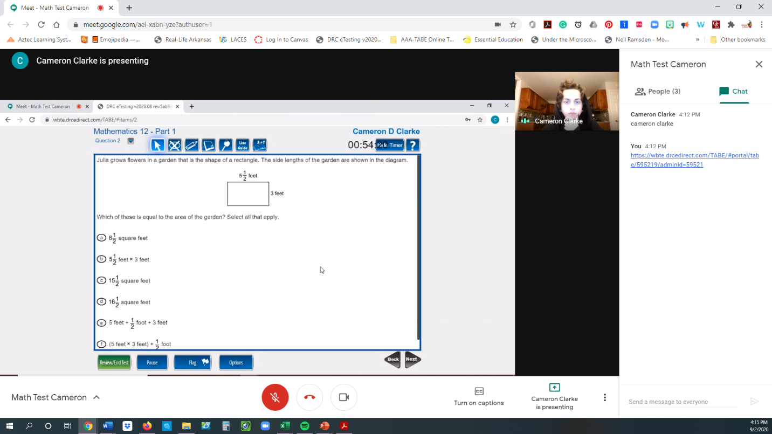 | - After you have your student sign in using the Chat, send them the link to the TABE testing website  - Tell the student to click ‘Present Now’ on the Google Meet menu (which appears as they move their mouse to the bottom or top of their screen) make sure they select ‘Entire Screen’. This will allow you to see all open tabs. Have them close the email tab that you sent the invite from. Now they should only have open the  - Have them log into the test. Either verbally give them their user id and password or paste it in the Chat box.  - Once they start presenting you will see, their picture in window, the open chat, and the screens they are presenting
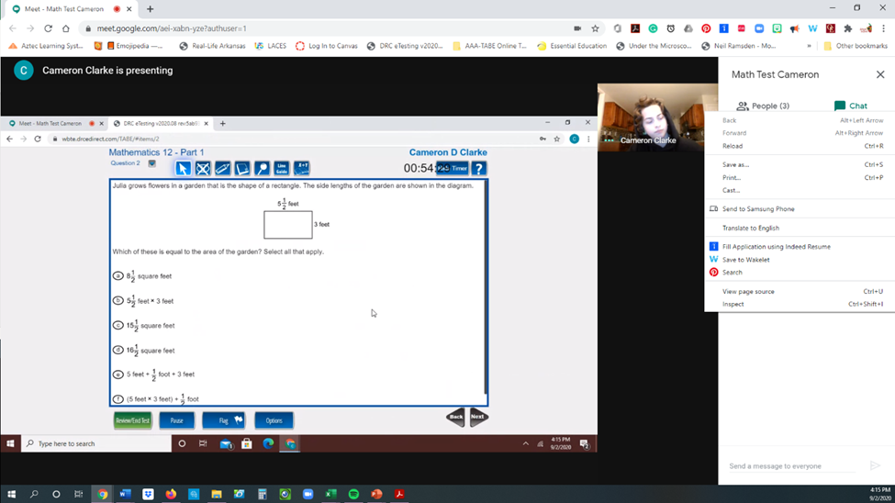 | - Once they are working on the test, you will Right Click with your mouse and bring up the quick menu and select the Print option.
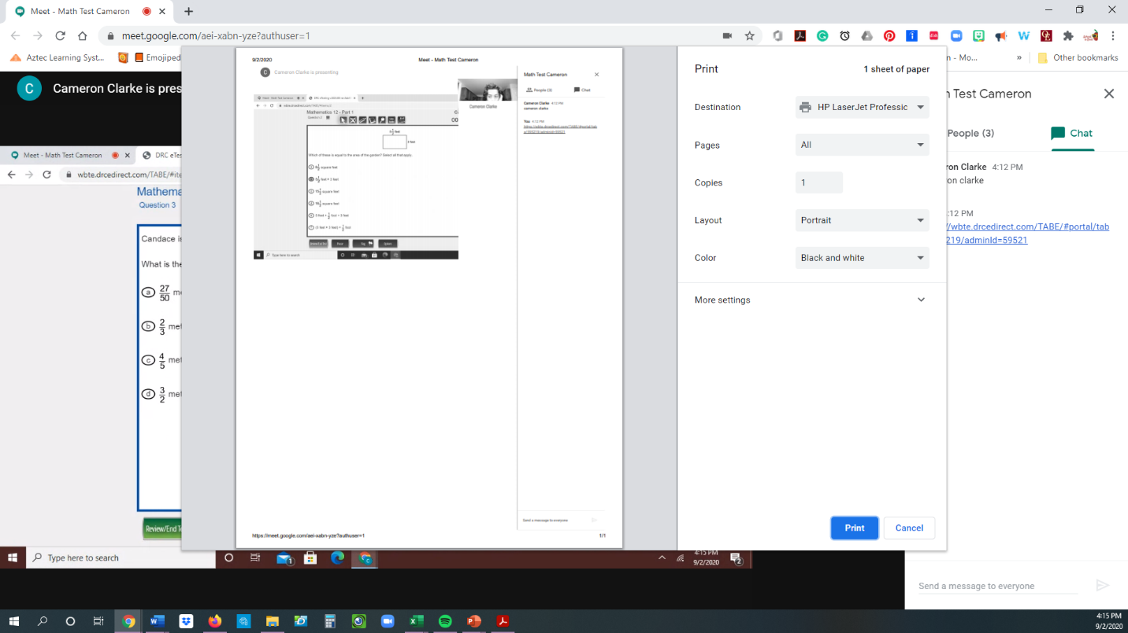 | - Click on the arrow beside the printer to view the drop down menu.
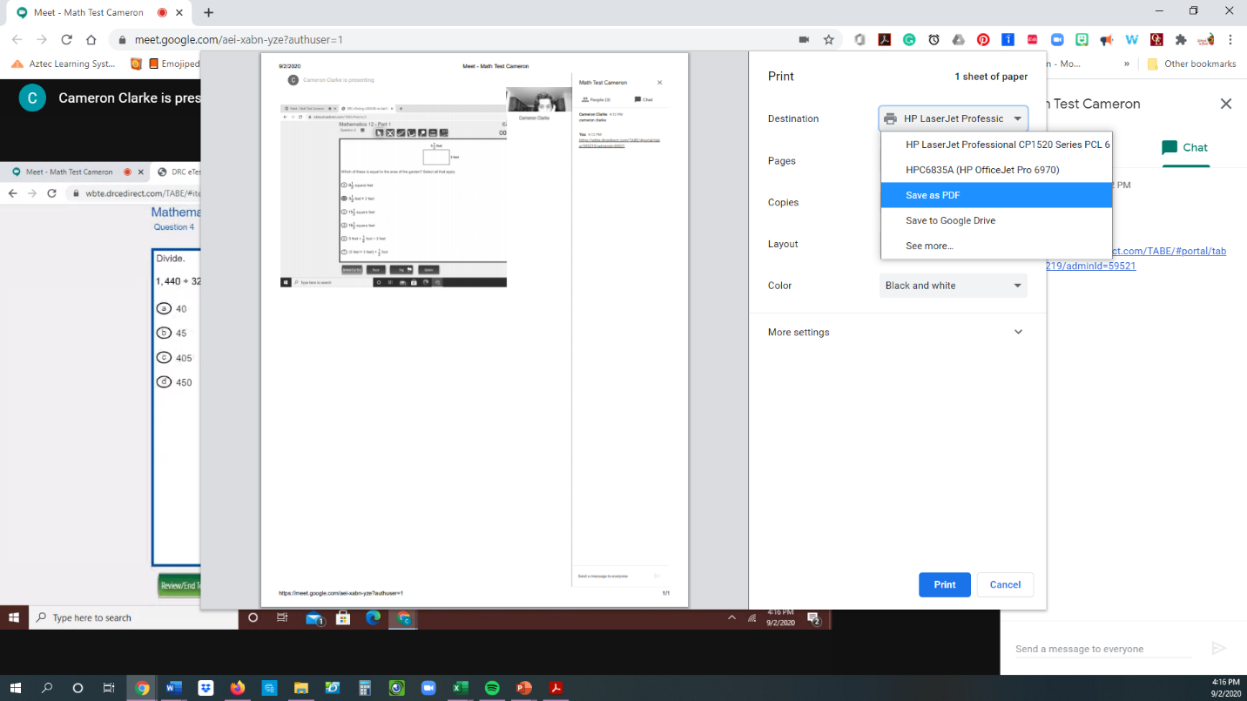 | - Select from the dropdown choices ‘Save as PDF’
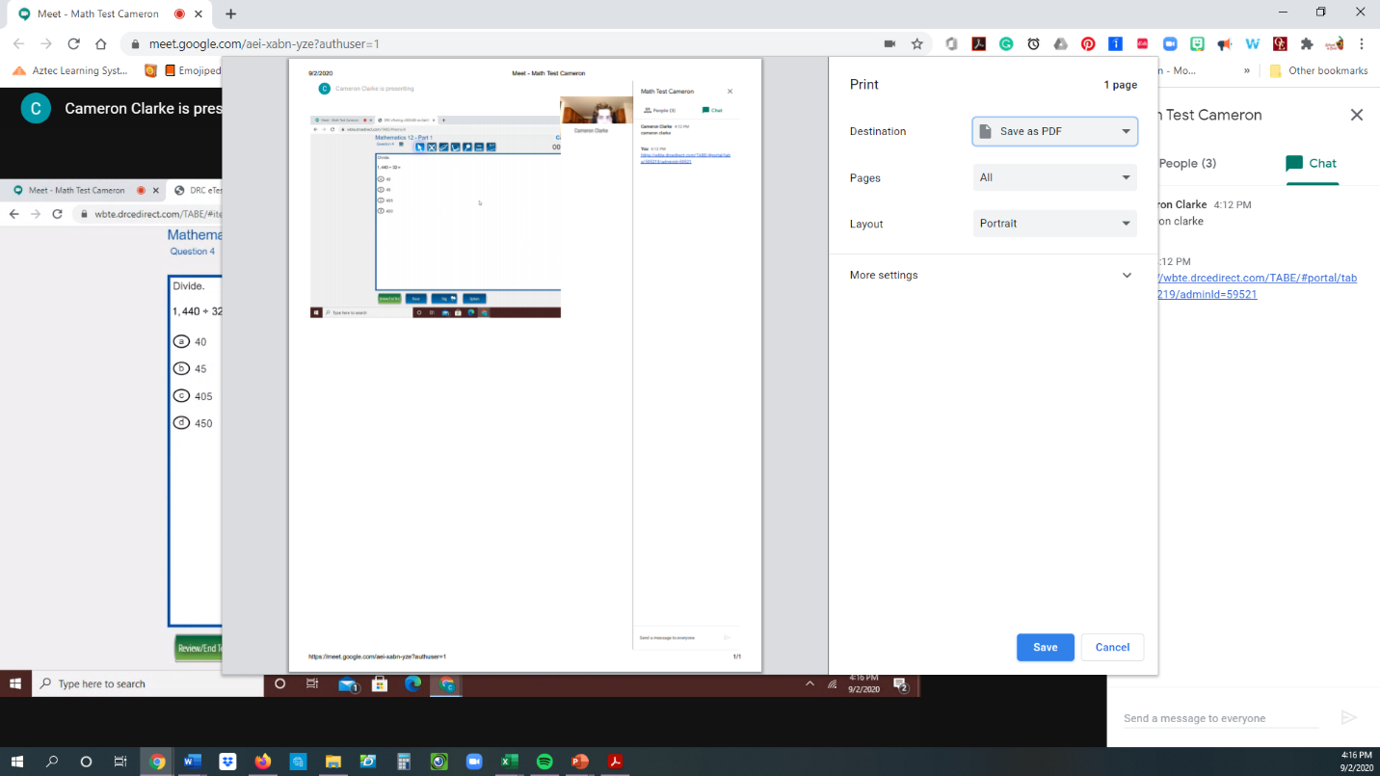 | - Click Save.
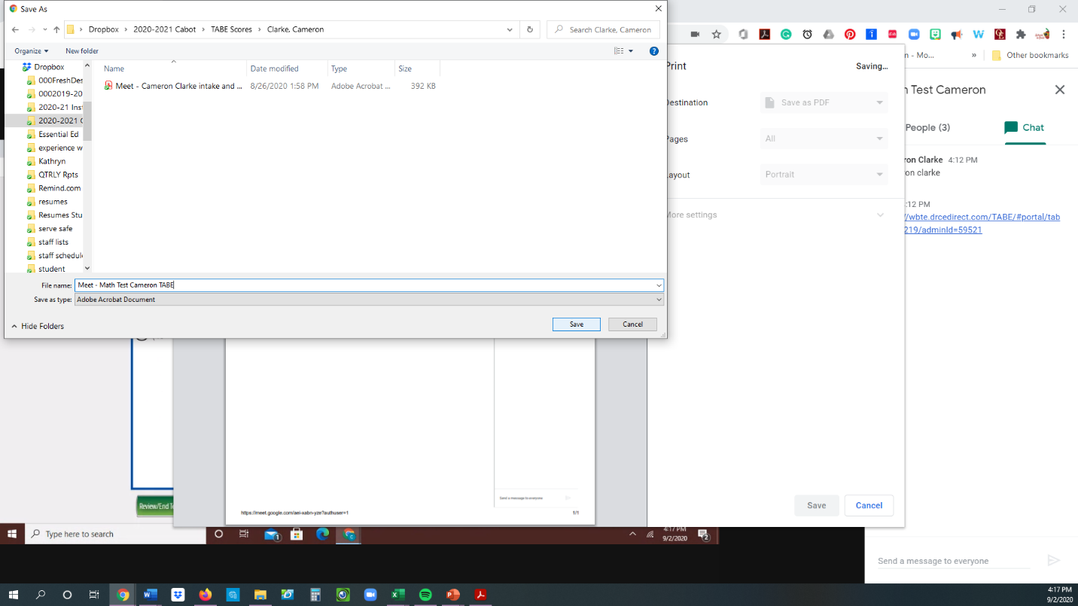 | - Choose the file folder where you would like the copy to be saved.  - Name the file and click save.

